**Reactor System #2:**

**Liquid-Phase High-Pressure Reactor**

Manual

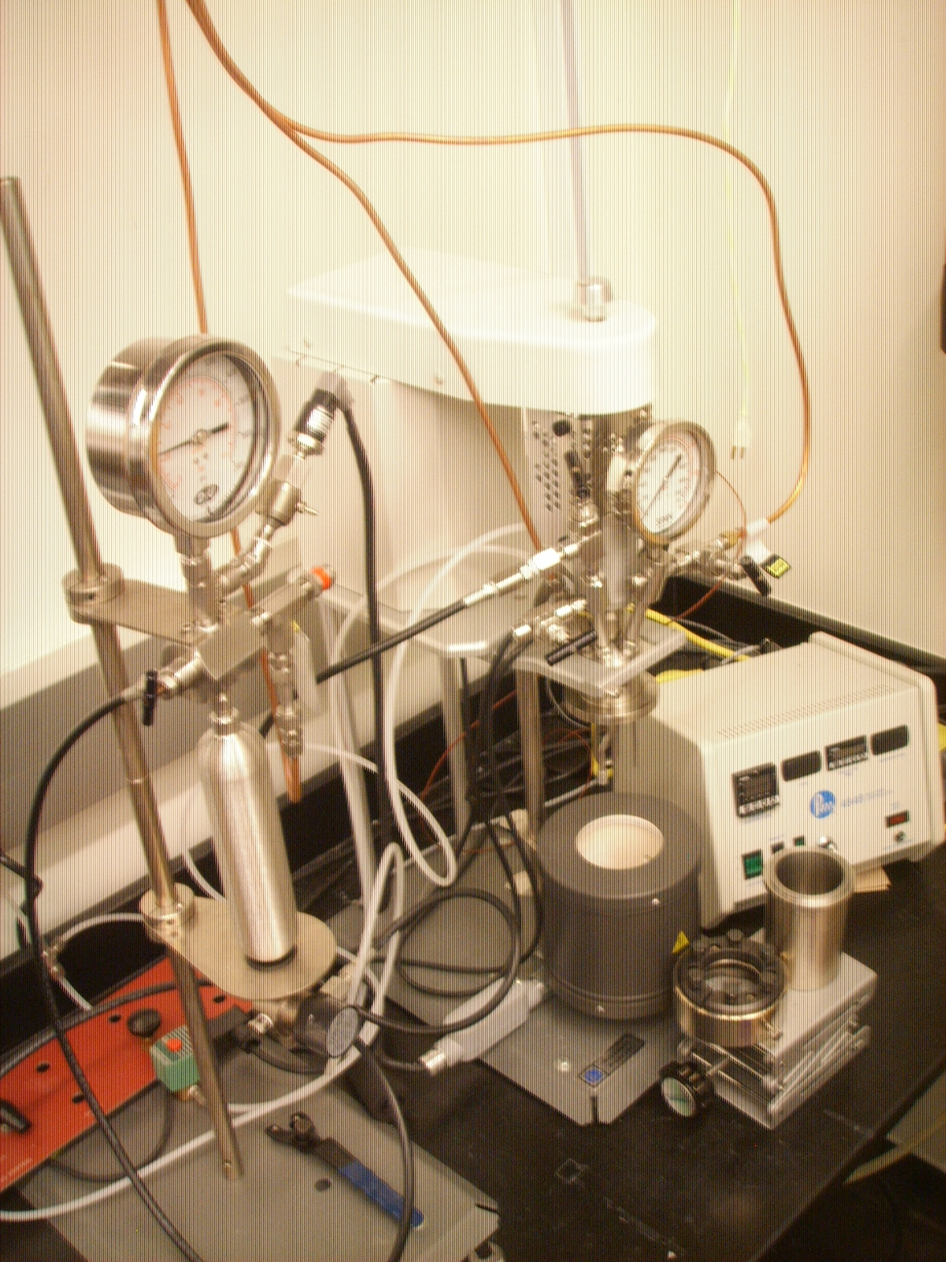

Francisco Zaera Group

Prepared by Zhihuan Weng, December 2013

Modified by Zihao Wang, November 2023

# Table of Content

1. General Laboratory Safety
2. General Considerations/Overview of Equipment
3. High-Pressure Reactor
   1. General Description
   2. Initial Setup
   3. Experimental Procedure
      1. Opening of the Vessel
      2. Introduction of the Reactants
      3. Pressurizing of the Vessel
      4. Withdrawing Liquid Aliquots for Analysis
   4. Maintenance and Troubleshooting
4. Typical Experiment Sequence
   1. Initial Steps
   2. Catalytic Runs and Sample Analysis
   3. Final Steps
5. Suggested Training for Beginners
6. Appendix A: 396MParr4560-Mini-Bench-Top-Reactors-InstParr Instructions
7. Appendix B: 230MParrSafety-Lab-Reactors
8. **General Laboratory Safety**

Before starting any experimental work in the laboratory, all users must learn The Laboratory Safety Manual and pass all exams. Users must also get familiar with the Injury and Prevention Program (IIPP) and Chemical Hygiene Plans (CHP).

All users must be familiar with the location of the fire extinguishers, safety showers, and other safety equipment before starting any experimental work. In Room CS 143:

1. Fire Extinguishers: Located next to front door of CS 143.
2. Safety Showers and Eyewash Station: Located next to the front door of CS 143.
3. Fire Exit: two doors in CS 143
4. First Aid Kits: Located next to front door of CS 143.

Some general points to keep in mind:

1. Always follow the laboratory safety procedures described in the appropriate documents when handling chemicals and electrical instruments.
   * + 1. **General Considerations/Overview of Equipment**

This is a Parr 4566, liquid-phase high-pressure reactor. An external burette is used to keep the internal pressure constant during reaction, and to follow the kinetic of reaction via analysis of the gas phase mixture. This setup is used to test a number of catalytic hydrogenation or oxidation reactions.

Key parameters:

1. Maximum pressure: 2000 Psi
2. Maximum temperature: 350 ℃
3. Stirring speed: 100-2000 rmp
4. **High-Pressure Reactor**

**a. General Description**

The liquid-phase high-pressure reactor is composed of the following parts (see Figure below)

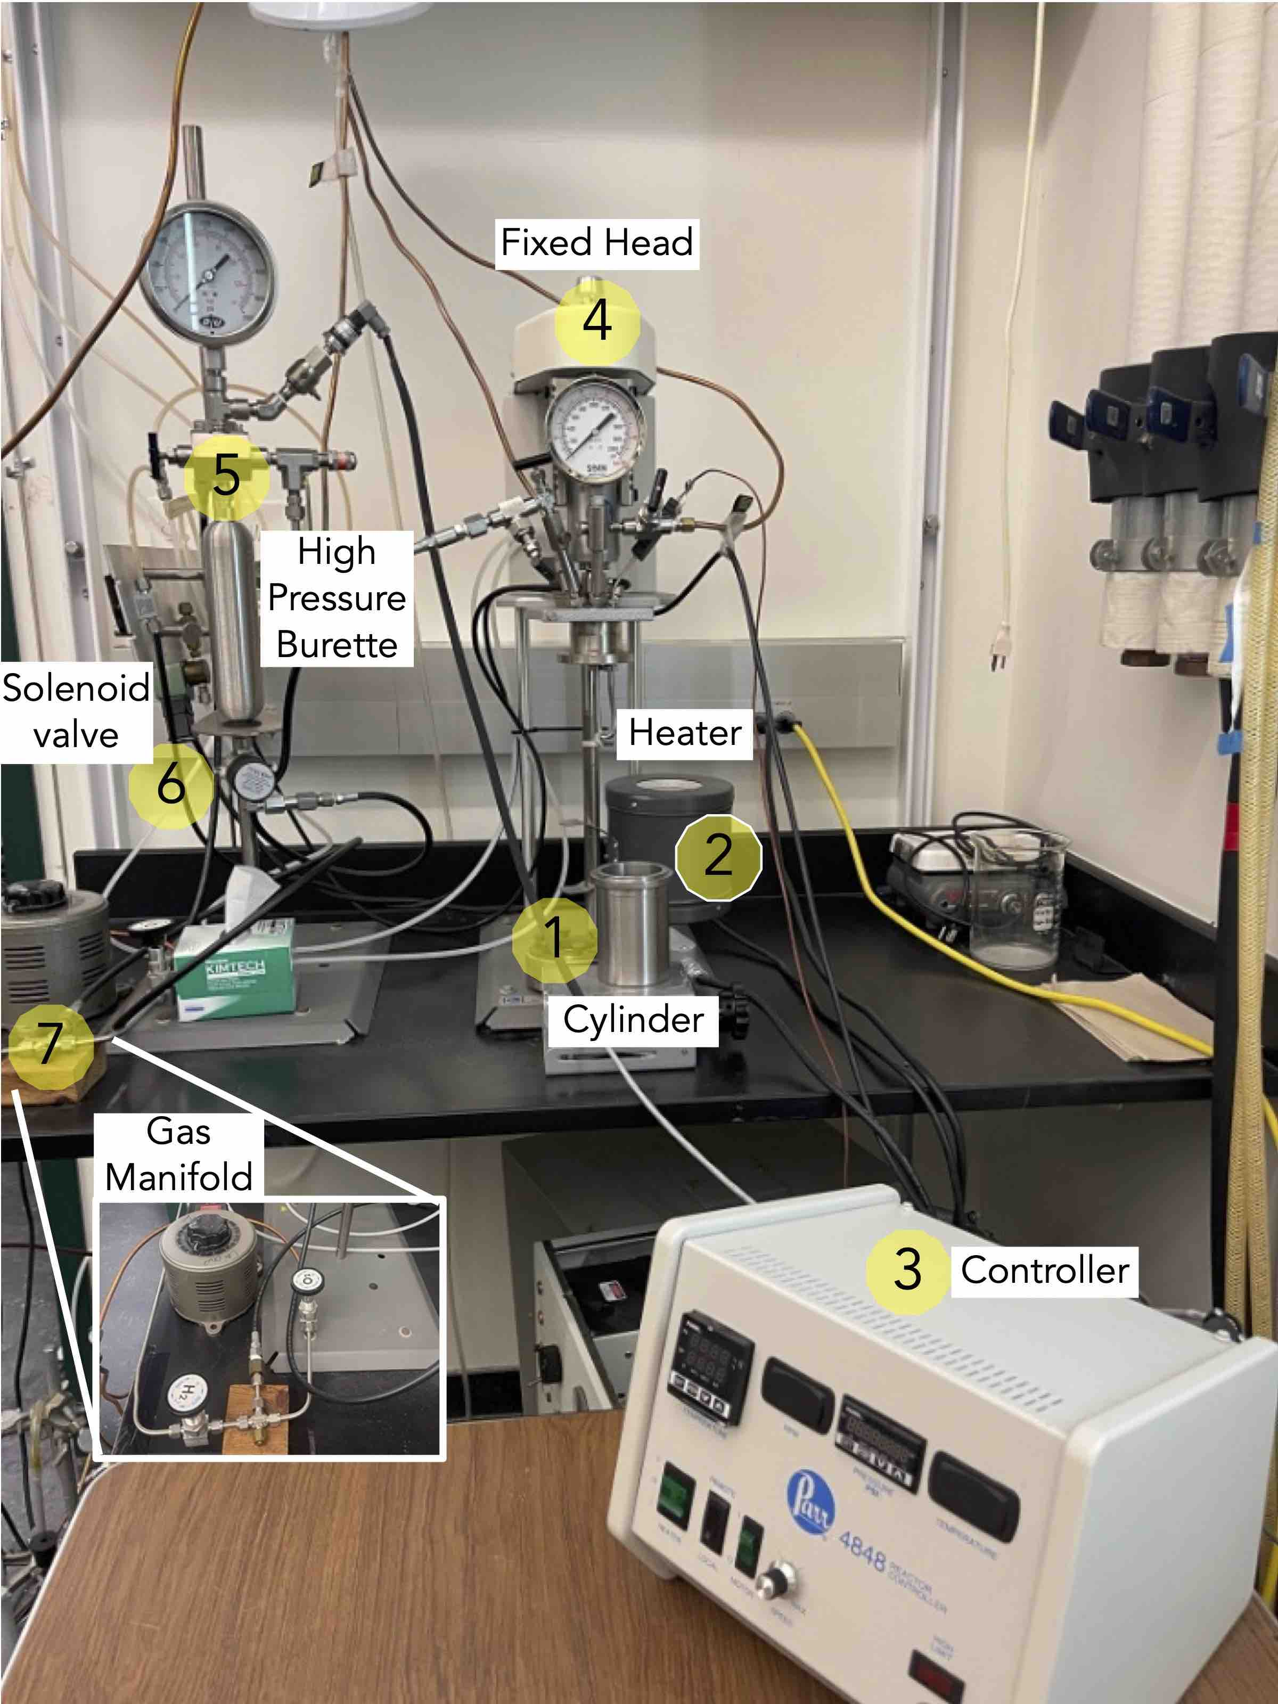

1. Cylinder: The volume of cylinder is 300 mL.
   1. As a general rule, the liquid charge should not exceed two-thirds of the capacity of the cylinder, in this case 200 mL.
2. Heater: heating is carried out using a mantle housed in a sturdy aluminum shell:
   1. Designed to proved uniform heating distribution to the wall and bottom of the vessel.
   2. Attached to the support rod with a clamp.
   3. Arranged so that it can be raised or lowered on the rod as desired.
3. Controller: Model 4848 Modular Controller
   1. It can control temperature, stirring speed, redundant temperature, and monitor pressure.
   2. It can datalog and be operated remotely from a PC.
4. Fixed head. A general schematic of the top fixed heat is provided in the figure below.

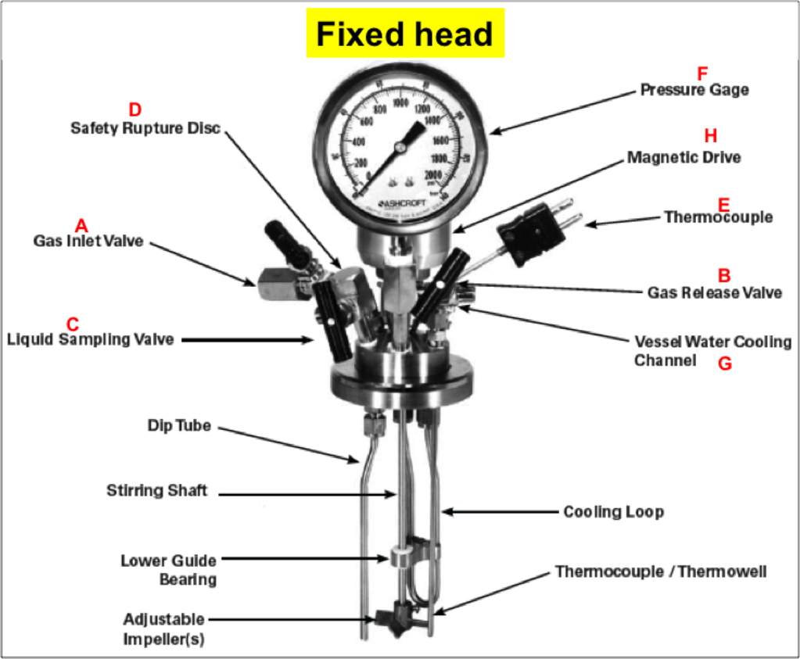

The Fixed head containing several valve and lines for the reactor:

* 1. Gas inlet valve:
     1. Easily identified when the vessel is open.
     2. Connected to a dip tube that extends to a point hear the bottom of the cylinder.
     3. With this arrangement, incoming gas is always introduced below the surface of the liquid.
  2. Gas release valve:
     1. Typically connected to a side opening on the gage adapter.
     2. Gas released from this valve will be drawn from the top of the reactor.
  3. Liquid sampling valve:
     1. Attached to the same fitting as the gas inlet valve and connected to the same dip tube.
     2. This provides the operator with a means for clearing the dip tube, to be sure that any sample taken during a run will be representative of the charge.
     3. Acquisition of sample aliquots is done by opening the upper gas inlet valve momentarily to allow the inlet gas to force any liquid in the dip tube back into the reaction before withdrawing a sample from the sampling valve.
  4. Safety rupture disc:
     1. Attached to the head.
     2. Intended to rupture and release the pressure before it reaches dangerous level.
  5. Type J thermocouple:
     1. To be connected to the socket on the rear panel of the temperature controller using the extension wire furnished with the reactor.
  6. Pressure gage:
     1. Has a T316 stainless steel Bourdon tube.
     2. The gage and the rupture disc should have matched ranges.
  7. Vessel water cooling channel:
     1. Single loop coil.
     2. Installed in the vessel with compression fittings.
     3. A slow, continuous flow of cold water through a cooling loop provides the means for controlling temperature overshoot, particularly when operating at temperatures below 150 oC.
     4. Water flow through the loop can be controlled automatically using a solenoid valve in the cold water line, and connected to the cooling socket on the rear panel of the Temperature Controller.
     5. With this arrangement, cold water can be admitted to the cooling loop whenever the controller calls for cooling.
  8. Magnetic Drive.

1. High pressure burette:
   1. Intended to introduce gas (commonly hydrogen) to a reactor at a constant pressure.
   2. Consists of a high-pressure reservoir equipped with:
      1. An inlet valve.
      2. A pressure gage.
      3. A relief valve.
   3. Included with each pipette are:
      1. A constant pressure regulator with a check valve.
      2. A connecting hose.
      3. A support stand.
   4. The amount of gas consumed in a reaction can be determined by knowing the volume of the high-pressure reservoir and observing the pressure drop in the reservoir during a reaction.
2. Solenoid valve for water line
3. Gas manifold
4. It has two gas, Hydrogen and Oxygen
5. The hydrogen cylinder is next to the reactor system in room 135.
6. The Oxygen cylinder is located in the cabinet along the hallway outside the room 135.
7. **Initial Setup**

The following points need to be kept in mind before conducting the experiments.

Before closing the vessel:

1. Examine the head gasket carefully to be sure that it is in good condition. After considerable use, some of the PTFE gasket may extrude and form thin, ragged edges around the inside and outside diameters. This does not necessarily mean that the gasket must be replaced. But the extruded portion should be removed with a sharp knife.
2. Examine the mating surfaces on the cylinder and head to be sure that they are clean and free from burrs.
3. Fill, but do not overfill, the vessel. As a general rule, the liquid charge should not exceed two-thirds of the capacity of the cylinder. Too much liquid in the vessel can lead to development of dangerous pressures if sufficient space is not provided for expansion when the liquid is heated.
4. Set the head on the cylinder and seal.

When pressurizing the reactor:

1. Always watch the pressure gauge closely so as to not exceed the maximum working pressure limit.
2. Remember that any subsequent increase in temperature will lead to a rise in pressure.

Pay attention when using hazard reagents:

1. Review the SOP of the materials to be used (liquids, solvents, reactants) before operation.
2. Remember that the reactor is not located in a fume hood, proceed accordingly when handling all compounds.
3. Protect yourself using appropriate PPE:
   1. Eye protection: Safety glasses with side shields should be worn.
   2. Skin and body protection: Wear a chemical resistant lab coat, long pants, and closed-toe shoes.
   3. Hand protection: At a minimum, wear nitrile chemical-resistant gloves.

**c. Experimental Procedure**

1. *Opening of the Vessel*
2. Open the gas release valve to discharge any internal pressure.
3. Loosen the six cap screws in the split ring sections (see Picture below).
4. Loosen the cone point screw in the outer band.
5. Lower the band to rest on the table.

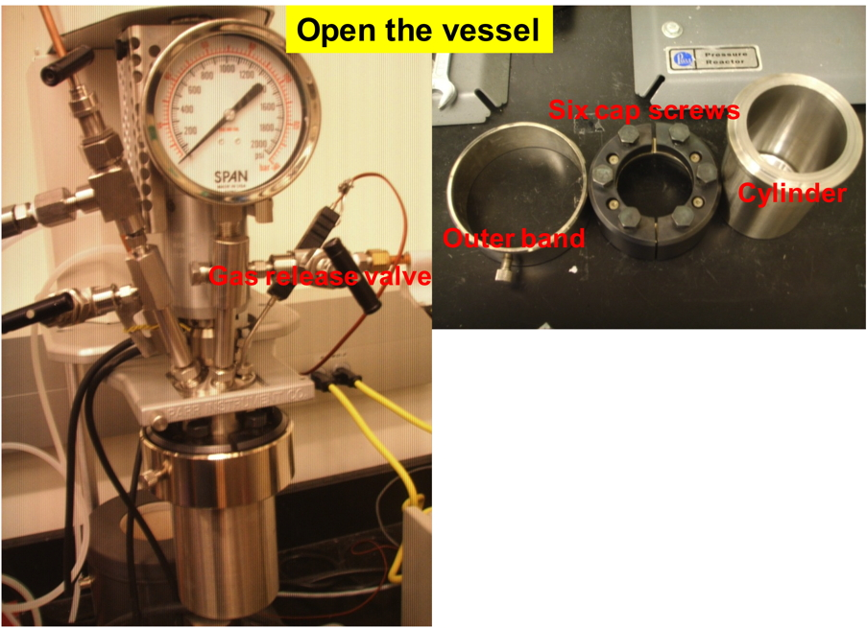

### Introduction of the Reactants

1. Add the solvent, reactants, solid catalyst and magnetic bar into the cylinder.
2. The amount of solvent should be around 6 mL; the liquid surface should not reach the magnetic motor stirrer.
3. Tighten the six cap screws.
4. Fix the outer band.



### Pressurizing of the Vessel

1. Always make certain that the pressure in the gas tank is greater than the pressure in the vessel, otherwise liquid will be forced out of the vessel and into the gas tank when the inlet valve is opened.
2. Check all valves carefully before admitting gas into the system:
   1. 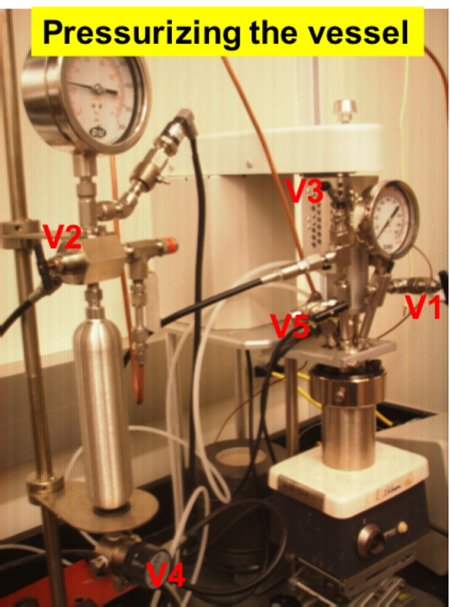The liquid sampling valve V5 must remain closed throughout the charging procedure (see Picture below).
   2. The gas release valve V1 must also be closed unless the vessel is to be purged (see Picture below).
3. Close valves V3 (inlet of vessel) and V4 (outlet of burette).
4. Open the main valve on the gas tank (see Picture below).
5. Open it only about one-quarter turn first.
6. Use the valve on the pressure regulator to control the flow of the gas into the burette (the pressure value should be higher than the ultimately reaction pressure).
7. Open valve V3.
8. Use valve V4 to control the flow of the gas into the vessel.
9. Before reaction, the vessel should be purged several times with H2.

### Withdrawing Liquid Aliquots for Analysis

As mentioned previously, under present reaction condition, the liquid surface can’t reach the dip tube. Therefore, the sampling valve cannot be used to withdraw the liquid sample.

1. Open the vessel as described above in Section *i*.
2. Extract a small amount of liquid from the reactor for analysis.
3. Pressurize the vessel again according to Section *iii*.
4. Continue the reaction until the next designed reaction time for sample analysis.
5. Repeat as many times as required by the experiment.
6. **Maintenance and Troubleshooting**
7. Periodically inspect all electrical wiring and pressure connections for corrosion. Suspect parts should be replaced by components supplied by Parr Instrument Company.
8. NPT (National Pipe Taper) threads should not be disassembled any more than necessary. It becomes increasingly more difficult to maintain a tight seal with these tapered threads if the jointsare made and broken repeatedly.
9. Do not use oil or anti-seize lubricant on threads or fitting if the vessel is to be used with oxygen.
10. Clean all threads and gas passages thoroughly and remove all tape fragments when overhauling a vessel.
11. Use an ultrasonic bath to clean the metal parts.
12. Do not place the thermocouple probe, pressure gauge, face seals, or ball bearings in the ultrasonic bath.
13. Periodic cleaning may be performed on the exterior surfaces of the reactor stand with a lightly dampened cloth containing a mild soap solution.
14. All electrical power should be disconnected when cleaning.
15. Routinely inspect the cap screws on the split ring closure for lubrication and cleanliness. It is important to clean and lubricate periodically so that the required torque is achieved when tightening the bolts.
16. If there is an internal leak on the gas inlet valve (V3) that allows gas goes from the gas tank into the vessel, try the following steps:
    * 1. Disassemble the gas inlet valve off from the system
      2. Open this valve (V3) to ensure not damage the sealing surface with following steps
      3. Loosen the union nut below the handle
      4. Tighten the packing nut (metal piece with two flats on it, which sticks out the union nut and the valve stem goes through)
17. **Typical Experiment Sequence**

Hydrogenation of ethyl pyruvate on Pt/A2O3 with cinchonidine in toluene was chosen as the typical experiment to show the operation in this reactor.

1. **Initial Steps**
   * + 1. Review the SOP of toluene, ethyl pyruvate, cinchonidine and Pt/Al2O3 located in room CS135.
       2. Wear a flammable-resistant lab coat, safety goggles and nitrile chemical-resistant gloves.
       3. Check the pressure of H2 gas cylinder is higher than 40 bar.
       4. Examine the head gasket carefully to be sure that it is in good condition. Also check the mating surface on the cylinder and head to be sure that they are clean and free from burrs.
2. **Catalytic Runs and Sample Analysis**
   * + 1. Open the vessel, and put the cylinder in fume hood.
       2. Add 25 mg of Pt/A2O3 (1 wt%, Sigma) into the cylinder, followed by 4.5 mL of anhydrous toluene, 1.5 mL of cinchonidine solution (prepared by dissolving 8 mg of cinchonidine in 50 mL anhydrous toluene), and 33 mg of ethyl pyruvate. And then add a stirring bar in the cylinder.
       3. The cylinder filled with reagents was connected with the head gasket via tightening the six cap screws, followed by the outer band.
       4. Open the valves of H2 gas tank, introduce the H2 into burette with the pressure is around 40 bar.
       5. Flush the reactor for five times with H2 at the pressure about 10 bar, and then pressurize the reactor with 20 bar for the hydrogenation.
       6. Start the reaction with stirring.
       7. After 20 min, stop the reaction, release the gas in reactor, move all of the mixture into a glass vial (VWR, 2Dr), centrifugate, take the clean liquid in up layer for conversion and enantioselectivity analysis by gas chromatography (Agilent 6890N equipped with a CP Chirasil-Dex CB, 25 m x 0.25 mm x 0.25 μm, chiral column).
3. **Final Steps**
   * + 1. Close the valve of H2 gas tank after finishing the hydrogenation.
       2. Clean the reactor and head gasket with acetone carefully, and dry them with air flow.
4. **Suggested Training for Beginners**

Emergency Action Plan (EAP) and Fire Prevention Plan (FPP)

Hazardous Waste Management

Laboratory Safety Manual & Chemical Hygiene Plan

Personal Protective Equipment (PPE)

Injury & Illness Prevention Plan (IIPP)

Laboratory Safety Orientation

Fire Extinguishers

Fume Hood Safety